________________________________________________________
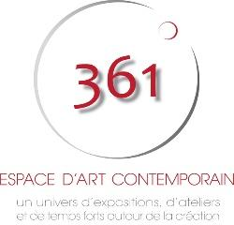
YOUNG TALENTS APPLICATION FORM

Which dates would best suit you ?
- january the 6th to february the 2nd 2020
- february the 3rd to march the 1st 2020
- march the 2nd to march the 29th 2020
_________________________________________________________________
First name :
last name :
Artist’s name :
Date of birth : ......../......../..............

City / State / Country :

Nationality :
Discipline :
- Drawing  - Painting  - Comics  - Photography  - Carving  - Illustration | - Urban Art  - Sculpture  - Installation  - 3D Animation  - Other

Phone number :
@mail :
Website / Facebook / Instagram /... :

